**CONTAINMENT ZONE ALERTING**

**APPLICATION**

NALAIYATHIRAN PROJECT BASED LEARNING

on

PROFESSIONAL READINESS FOR INNOVATION, EMPLOYABILITY AND ENTREPRENEURSHIP

**A PROJECTREPORT**

|  |  |
| --- | --- |
| **BANGARU LAKSHMANAN** | **19104032** |
| **GANESHAN S** | **19104054** |
| **ALLEN LUBIN** | **19104016** |
| **DHINESH KUMAR** | **19104049** |

BACHELOR OF ENGINEERING

IN

COMPUTER SCIENCE

**HINDUSTHAN COLLEGE OF ENGINEERING AND TECHNOLOGY**

Approved by AICTE, NewDelhi, Accredited with‘ A’ Grade by NAAC

**(An Autonomous Institution, Affiliated to AnnaUniversity, Chennai)**

**COIMBATORE–641032**

**November2022**

**TABLE OF CONTENTS**

|  |  |  |
| --- | --- | --- |
| **S.NO** | **TITLE** | **PAGENO** |
| **1** | **INTRODUCTION** | 04 |
| **1.1** | Project Overview | 04 |
| **1.2** | Purpose | 04 |
| **2** | **LITERATURESURVEY** |  |
| **2.1** | Existing Problem | 04 |
| **2.2** | Reference | 07 |
| **2.3** | Problem Statement Definition | 07 |
| **3** | **IDEATION AND PROPOSED SOLUTION** |  |
| **3.1** | Empathy map Canvas | 08 |
| **3.2** | Ideation and Brainstroming | 09 |
| **3.3** | Proposed Solution | 09 |
| **3.4** | Problem Solution Fit | 10 |
| **4** | **REQUIREMENT ANALYSIS** |  |
| **4.1** | Functional Requirements | 13 |
| **4.2** | Nonfunctional Requirements | 14 |
| **5** | **PROJECTDESIGN** |  |
| **5.1** | Data Flow Diagram | 15 |
| **5.2** | Solution and Technical Architecture | 16 |
| **5.3** | User Stories | 18 |
| **6** | **PROJECTPLANNINGAND SCHEDULING** |  |
| **6.1** | Sprint Planning and Estimation | 23 |
| **6.2** | Sprint Delivery Schedule | 30 |
| **6.3** | Reports from Jira | 31 |
| **7** | **CODING AND SOLUTIONING** |  |
| **7.1** | Feature 1 | 33 |
| **7.2** | Feature 2 | 33 |
| **8** | **TESTING** |  |
| 8.1 | Testcases | 33 |
| 8.2 | User Acceptance Testing | 34 |
| **9** | **RESULTS** |  |
| **9.1** | Performance Metrics | 35 |
| **10** | **ADVANTAGE AND DISADVANTAGE** | 36 |
| **11** | **CONCLUSION** | 37 |
| **12** | **FUTURE SCOPE** | 37 |
| **13** | **APPENDIX** | 38 |
|  | **SOURCE CODE** | 39 |
|  | **GITHUB & PROJECT DEMO LINK** |  |

1. **INTRODUCTION**

# Project Overview

This application is intended to provide information about containment zones in a particular region by alerting people, through continuous monitoring of an individual's location. Key beneﬁts of the application are monitoring people's activity and alerting them of their safety movements.

# Purpose

The project aims at building an application that provides information about the containment zones of a particular region by continuously monitoring an individual's location. Location of the individual must be stored in the Database. Alerts are sent using the notiﬁcation service.

# LITERATURE SURVEY

**Existing problem**

**TITLE:** Development of An AndroidApplication for ViewingCovid- 19

Containment Zones Alerting.

Department of Instrumentation and Electronics Engineering, Jadavpur University, Salt Lake Campus, Kolkata,700 098, India Ranajoy Mallik,Amlan Protim Hazarika,Sudarshana GhoshDastidar, Dilip Sing & Rajib Bandyopadhyay

The World Health Organization has declared the outbreak of the novel coronavirus, Covid-19 as pandemic across the world. With its alarming surge of affected cases throughout the world, lockdown, and awareness (social distancing, use of masks etc.) among people are found to be the only meansfor restricting the community transmission. In a denselypopulated country likeIndia, it is very diﬃcult to prevent the community transmission even during lockdownwithout social awarenessand precautionary measurestaken by the people. Recently,several containment zones had been identiﬁed throughout the country and divided into red, orangeand green zones, respectively. The red zones indicate the infection hotspots, orange zones denote some infection and green zones indicate an area with no infection. This paper mainly focuses on development of an Androidapplication which can inform people of the Covid-19 containment zones and prevent trespassing into these zones. This Android application updates the locations of the areas in a Google map which are identiﬁed to be the containment zones. The application also notiﬁes the users if they have entered a containment zone and uploadsthe user’s IMEI number to the online database. To achieve all these functionalities, many tools, and APIs from Google like Firebase and Geofencing API are used in this application. Therefore, this application can be used as a tool for creating furthersocial awareness about the arisingneed of precautionary measures to be taken by the people of India.

**TITLE:** Aarogya Setu

National Informatics Centre, Ministry of Electronics & Information Technology, Governmentof India.

The most popular containment zone alert application among the options currently in use in India is called Aarogya Setu. The Indian government created

a mobile application to link the public with crucial health services. Its primary features include geo-location-based COVID- 19 data, user risk status, automatic contact tracing using Bluetooth, and much more. The movement of an infected individual is tracked using Bluetooth and GPS technology, and the system notiﬁes the public of the locations the infected person has visited while designating those locations as vulnerable ones. It employs cellular triangulation to determine a person's location in the absence of GPS technology. While Aarogya Setu can track down contacts and

notify those who have come into touch with someone who has COVID-19, it also activelykeeps track of quarantine or containment zones and alerts users who enter them.

The Terms of Use and Privacy Policy must be accepted at the time of registration when installing the application on any Android or iOS mobile device, and ongoing use of the application denotescontinued acceptance. Name, age, sex, occupation, phone number, overseastravel within the previous 28–45 days, and whether the user is a smokerare all pieces of information that the app gathers.

This data is kept on a server that is under the jurisdiction of the Indian government. It is hashed and sent to the user's mobile application along with a special digital ID (DID). The user is recognised using the DID. In order for the user's mobilephone to exchangeinformation with anotherdevice that has the app when it gets within range, the Bluetooth and GPS servicesmust be turned on.

Their individual IDs, along with the time and GPS location, are kept on the two phones when two users come into close proximity. The format in which this data is kept is encrypted. Only after aperson tests positiveis it posted to the government-controlled serversof the app.

**TITLE:** Containment Zones and Monitoring Violators Who areTrespassing into It Using Firebase and Geofencing

Ranajoy Mallik ,Amlan Protim Hazarika ,Sudarshana Ghosh Dastidar

,Dilip Sing ,RajibBandyopadhyays

In this study, the authors concentrated on creating a mobile application to deliver details about the Covid-19 containment zones in West Bengal. The programme also keeps track ofthe user's whereabouts and sends an alarm if the user enters a containment zone.To keep usersinformed, the application also offers daily Covid-19 case statistics. The application is made with the Android SDK, and the location information is kept in the Firebase Cloud Firestore. The containment zones are surrounded by geofences made using the Android geofencing client,and notiﬁcations are sent using the notiﬁcation manager. To displaythe Covid-19 cases in West Bengal, the application also makes use of RESTful web services.

They tested their app with a variety of users in various West Bengal areas, and they discovered that it operated effectively and helped them reach their goal.

**TITLE:** Tracking the Covid zones throughgeo-fencing technique

Anto ArockiaRosaline R ,LalithaR ,Hariharan G ,Lokesh N

Following the tracking of a suspicious person, the geo-fenced layer is mapped out in the vicinity,and the virtual perimeter is then employedfor the subsequent trapping procedure. As soon as the Covid monitoring team updates this geo-fenced layer, the public can view it. The idea of creating a virtual perimeter region is known as geo-fencing. Effective containment zone monitoring is made possibleby this virtual perimeter monitoring technology. By utilisingan automated system based on wireless infrastructure, it lowers operational costs. Additionally, it promptly alerts the law enforcement to ﬁnd the offenders. As a result, it facilitates the inspection of containment areas and the monitoring of those who disobeygovernmental regulations.

Users can receive updates from the Covid team on the alert zone. The Covid team has a number of modules for suspect tracking, hotspot fencing, etc. The Covid team must seek a service from the service network provider in the case of suspect tracking, and following authorization, they will offer the coordinates. According to our telecommunication legislation, it is illegal to share data; nonetheless, exchanging personal information withoutthe individual's knowledge via any means is occasionally allowed with governmental approval for investigative purposes.

**TITLE:** Geofencing 2.0: Taking Location-based Notiﬁcations tothe Next Level

Sandro RodriguezGarzon Bersant Deva

The basic Android application that served as the prototype Geofencing client was used. This client is primarily responsible for carrying out the geofencing server's ongoing locationupdate strategy. This must be accomplished with little energy consumption because the Geofencing client is located on a mobile device. We made the decision to employ the low energy Geofencing features of the Android operating system to keep an eye on the safety zone. As a result, a safety zone is considered as a single circular geofence with a required exit on the mobile device. However, they discovered that there was occasionally a signiﬁcant lag time between leaving the safetyzone and receiving a notiﬁcation from the system about the leave.

In order to address this issue, a speciﬁc amount of the safety zone's radius is decreased. While the safety zone and how it is implemented have a signiﬁcant impact on overall energy consumption, it is also important to make the right choice when it comes to a placement mechanism. In order to reduce powerconsumption without compromising the necessary position precision, they used a device-based smart combination of various positioning mechanisms introduced by. By temporarily deactivating placement when a device is not in motion, the Geofencing client also makes use of cutting-edge mobile sensing capabilities integrated into the Androidoperating system's activityrecognition unit. Mobileusers who live close to a geo-border fence's will ﬁnd this to be of particular utility. If the Geofencing server notiﬁes the Geofencing clientabout a geo-notice, the notiﬁcation will appear right away.

# Reference

https://[www.researchgate.net/publication/341298994_Development_of_an_Andr](http://www.researchgate.net/publication/341298994_Development_of_an_Andr) oid_application_for_viewing_Covid19_containment_zones_and_monitoring_violat ors_who_are_trespassing_into_it_using_Firebase_and_Geofencing

https://[www.ncbi.nlm.nih.gov/pmc/articles/PMC7328652/](http://www.ncbi.nlm.nih.gov/pmc/articles/PMC7328652/)

https://link.springer.com/article/10.1007/s41403-020-00137-3

https://pesquisa.bvsalud.org/global-literature-on-novel-coronavirus-2019 ncov/resource/pt/covidwho-620108

# Problem Statement Deﬁnition

Problem Statement1:

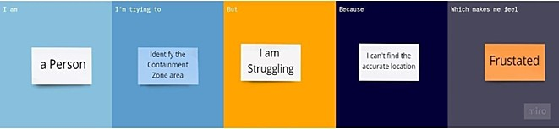

Problem Statement2:

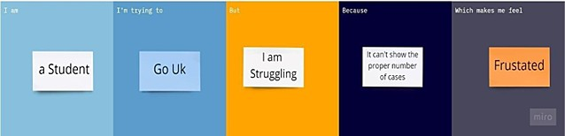

Problem Statement3:

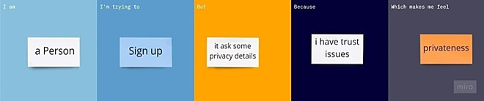

Problem Statement4:

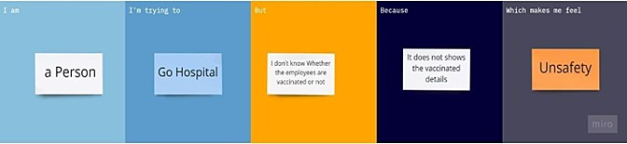

# IDEATION & PROPOSED SOLUTION

**Empathy Map Canvas**

An empathy map is a simple, easy-to-digest visual that capturesknowledge about a user’s behaviours and attitudes.

It is a useful tool to helpsteams better understand their users. Creating an effective solution requires understanding the true problem and the person who is experiencing it. The exercise of creating the map helps participants consider things from the user’s perspective along with his or her goals and challenges.

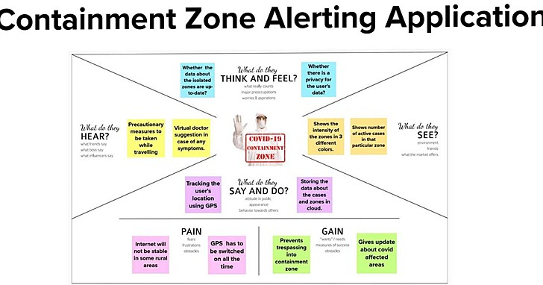

# Ideation & Brainstorming

Brainstorming provides a free and open environment that encourages everyone within a team to participate in the creative thinking process that leads to problem solving. Prioritizing volume over value, out-of-the-box ideas are welcome and built upon, and all participants are encouraged to collaborate, helping each other develop a rich amount of creative solution.

# Proposed Solution

|  |  |  |
| --- | --- | --- |
| **S.No**  **.** | **Parameter** | **Description** |
| 1. | **Problem Statement**  **(Problem to be solved)** | This application is intended to provide  information about containment zones in a  particular region by alerting people, |

|  |  |  |
| --- | --- | --- |
|  |  | through continuous monitoring of an individual's location. Key beneﬁts of the  application are monitoring people's activity and alerting them of their safety movements. |
| 2. | **Idea / Solution description** | The project aims at building an application that provides information about the containment zones of a particular region by continuously monitoring an individual's location.  Location of the individual must be stored in the Database. Alerts are sent  using the notiﬁcation service. |
| 3. | **Novelty / Uniqueness** | The uniqueness of containment zone alerting app is it shows the particular area of the district before the 100m, and the user's location history is stored  in database  and this app provides the precautions measurements, list of immunity boosters, location of the vaccination providing places. it also gives the list of  the affected and admitted patients and  discharged patients, percentage of affecting by covid19 |
| 4. | **Social Impact / Customer** | Social Stigma is discrimination against |

|  |  |  |
| --- | --- | --- |
|  | **Satisfaction** | a particular group of people, a place, or  a nation in the form of a negative attitude. Public health emergencies (such as COVID-19 pandemic) are stressful situations for people and  communities. |

|  |  |  |
| --- | --- | --- |
|  |  | Fear and anxiety with a lack of knowledge about the disease can lead  to social stigma. Customer Satisfaction:  The containment zone alerting app users are 100% satisﬁed because of its  immediate notiﬁcation of a particular area and it provides the precautions, it gives the awareness about the covid  19 seriousness. |
| 5. | **Business Model (Revenue Model)** | We are going to add personal health tracker in subscription basis .so they  can manage their health eﬃciently. |
| 6. | **Scalability of the Solution** | In this modern world even though the covid pandemic threat is about to end there are high chance of pandemic or endemic .so this application is very useful in that situation and we can use  this application in seasonal diseases |

* 1. **Problem Solution ﬁt**

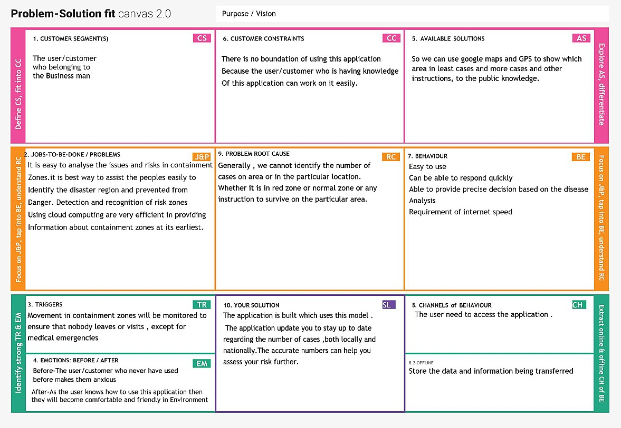

# REQUIREMENT ANALYSIS

* 1. **Functional requirement**

Following are the functional requirements of the proposed solution.

|  |  |  |
| --- | --- | --- |
| **FR No.** | **Functional Requirement (Epic)** | **Sub Requirement (Story / Sub-Task)** |
| FR-1 | **User Registration** | Registration through Gmail. Registration through mobile number. |
| FR-2 | **User Conﬁrmation** | Conﬁrmation via Email and OTP. |

|  |  |  |
| --- | --- | --- |
|  |  |  |
| FR-3 | **Authentication** | It veriﬁes the conﬁrmation of the password. |
| FR-4 | **Business rule** | For subscriber's we give ﬁrst 3 day's free trail. For  unsubscribes the user needs to watch some  advertisement for knowing the zone alert for ﬁrst 3  days. |

# Non-Functional requirements

Following are the non-functional requirements of the proposed solution.

|  |  |  |
| --- | --- | --- |
| **FR No.** | **Non-Functional Requirement** | **Description** |
| NFR-1 | **Usability** | Providing recommendation link by using customer  preference. |
| NFR-2 | **Security** | The software team will issue some strong security  code for the users. |
| NFR-3 | **Reliability** | The database update process must rollback all  related updates when any update fails. |
| NFR-4 | **Performance** | The loading speed of the server is quick  and fast. |

|  |  |  |
| --- | --- | --- |
|  |  |  |
| NFR-5 | **Availability** | Stands for the system's reliability and accessibility to  the user. |
| NFR-6 | **Scalability** | The website is enough to support almost 1,00,000  users at a time. |

# PROJECT DESIGN

* 1. **Data Flow Diagrams**

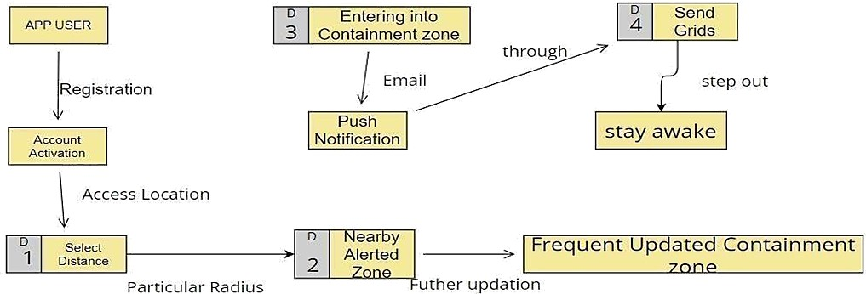

# Solution & Technical Architecture

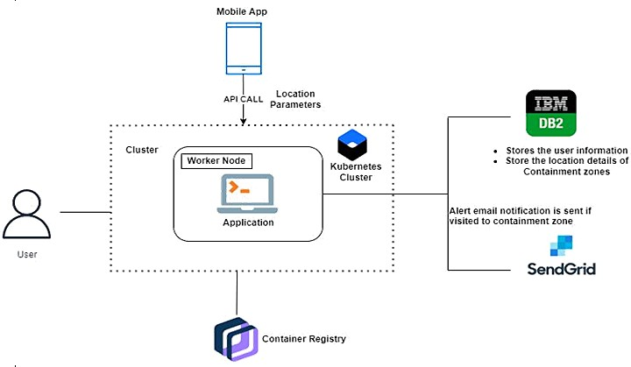

**Table-1 : Components & Technologies:**

|  |  |  |  |
| --- | --- | --- | --- |
| **S.No** | **Component** | **Description** | **Technology** |
| 1. | User Interface | How user interacts with application e.g. Web  UI, Mobile App, etc. | HTML, CSS,  JavaScript etc. |
| 2. | Application Logic-1 | Logic for a process in the application | Java / Python |
| 3. | Application Logic-2 | Logic for a process in the application | IBM Watson STT service |
| 4. | Application Logic-3 | Logic for a process in the application | IBM Watson Assistant |

|  |  |  |  |
| --- | --- | --- | --- |
| 5. | Database | Data Type, Conﬁgurations etc. | MySQL, NoSQL, etc. |
| 6. | Cloud Database | Database Service on Cloud | IBM DB2, IBM etc. |
| 7. | File Storage | File storage requirements | IBM Block Storage or Other Storage Service or Local Filesystem |
| 8. | External API-1 | Purpose of External API used in the application | IBM Weather API, etc. |
| 9. | External API-2 | Purpose of External API used in the application | Aadhar API, etc. |
| 1  0. | Infrastructure (Server / Cloud) | Application Deployment on Local System / Cloud Local Server Conﬁguration:  Cloud Server Conﬁguration : | Local, Cloud Foundry, Kubernetes, etc. |

# Table-2: Application Characteristics:

|  |  |  |  |
| --- | --- | --- | --- |
| **S.No** | **Characteristics** | **Description** | **Technology** |
| 1. | Open-Source Frameworks | List the open-source frameworks used | Fire wall |

|  |  |  |  |
| --- | --- | --- | --- |
| 2. | Security Implementations | List all the security / access controls implemented,  use of ﬁrewalls etc. | Encryptions, IAM Controls, etc. |
| 3. | Scalable Architecture | Justify the scalability of architecture | IBM DB2 |
| 4. | Availability | Justify the availability of application | Google map services |
| 5. | Performance | Design consideration for the performance of the application (number of requests per sec, use of  Cache, use of CDN’s) etc. | IBM cloud |

1. **User Stories**

|  |  |  |  |  |  |  |
| --- | --- | --- | --- | --- | --- | --- |
| **User Type** | **Functional Requirem ent**  **(Epic)** | **User Story Numb er** | **User Story / Task** | **Acceptance criteria** | **Priori ty** | **Release** |
| Customer | Registrati on | USN-1 | As a user, I can register for the applicati  on by | I can access my account / | High | Sprint-1 |

|  |  |  |  |  |  |  |
| --- | --- | --- | --- | --- | --- | --- |
| (Mobile user) |  |  | my email, passwor d, and conﬁrmi ng  my passwor d. | dashboard |  |  |
|  |  | USN-2 | As a user, I will receive conﬁrmat ion email once I have register ed for the applicati on | I can receive conﬁrmation  email & click conﬁrm | High | Sprint-1 |
|  |  | USN-3 | As a user, I can register for the applicati on through Facebook | I can register & access the dashboard with Facebook Login | Low | Sprint-2 |
|  |  | USN-4 | As a user, I can  register |  | Medi um | Sprint-1 |

|  |  |  |  |  |  |  |
| --- | --- | --- | --- | --- | --- | --- |
|  |  |  | for the applicati on through Gmail |  |  |  |
|  | Login | USN-5 | As a user, I can log into the applicati on by entering email & password |  | High | Sprint-1 |
|  | Dashboa rd | USN-6 | As a User  , Can I manually plot the alerted zone  for my convenie nce only. | It can be viewed in the  user dashboard | Low | Sprint - 2 |
| Customer (Web  user) | Registrati on | USN-1 | As a user, I can register for the applicati on by entering my email, passwor d, and conﬁrmi | User account activities can  be viewed in dashboard. | High | Sprint - 2 |

|  |  |  |  |  |  |  |
| --- | --- | --- | --- | --- | --- | --- |
|  |  |  | ng my  passwor d. |  |  |  |
|  |  |  | Conﬁrma tion code has been send through the register ed mail id  ,phone number |  |  |  |
|  | Location Access | USN-2 | As a User  , I can viewed into the page , if there is any condition to access the location | Locati turn on can beed  through Control center | High | Sprint - 2 |
|  | Contamin ated | USN-3 | Is it accurate ly show off the  alerted | Alert messa  ed ges are | High | Sprint - 3 |

|  |  |  |  |  |  |  |
| --- | --- | --- | --- | --- | --- | --- |
|  | Zones |  | zone If  I Entered into the zone the messag es are properly received through email. | sendgri  send by ds  through the registered mail  id |  |  |
| Administr ator | Frequent Updates | USN-4 | Admin are necessa ry to updates the recent containm ent through their portals and these seen throught the app. | It can be accessed by Geo  fencin g. | Medi um | Sprint - 4 |

# PROJECT PLANNING & SCHEDULING

* 1. **Sprint Planning & Estimation**

|  |  |  |  |  |  |  |
| --- | --- | --- | --- | --- | --- | --- |
| **Spri** | **Function** | **User** | **User Story /** | **Sto** | **Priori** | **Team** |
| **nt** | **al** | **StoryNum** | **Task** | **ry** | **ty** | **Members** |
|  | **Requirem** | **ber** |  | **Poin** |  |  |
|  | **ent (Epic)** |  |  | **ts** |  |  |

|  |  |  |  |  |  |  |
| --- | --- | --- | --- | --- | --- | --- |
|  | Registration | USN-1 | User: I can register for theapplication byentering my email,password and verifying  password. | 3 | High | Bangaru lakshmanan |
| Sprint- 1 |  |  |  |  |  |  |
|  |  | USN-2 | User: I will | 2 | High |  |
|  |  |  | receive a |  |  |  |
|  |  |  | conﬁrmati |  |  | Ganeshan s |
|  |  |  | onemail |  |  |  |
|  |  |  | once I |  |  |  |
|  |  |  | have |  |  |  |
|  |  |  | registered |  |  |  |
|  |  |  | for the |  |  |  |

|  |  |  |  |  |  |  |
| --- | --- | --- | --- | --- | --- | --- |
|  |  |  | applicatio |  |  |  |
|  | n. |
|  | USN-3 | User: I can | 5 | Medi | Dhinesh kumar |
|  |  | register for |  | um |  |
|  |  | the |  |  |  |
|  |  | application |  |  |  |
|  |  | through |  |  |  |
|  |  | Gmail. |  |  |  |
|  | USN-4 | Managemen | 2 | High | Allen lubin |
|  |  | t: I need to |  |  |  |
|  |  | register my |  |  |  |
|  |  | hospitals on |  |  |  |
|  |  | thesite. |  |  |  |
|  | USN-5 | User: I can | 3 | High | Ganeshan s |
|  |  | log into the |  |  |  |
| Login |  | application |  |  |  |
|  |  | byentering |  |  |  |
|  |  | my email & |  |  |  |
|  |  | password |  |  |  |
|  | USN-6 | Managemen | 5 | Medi | Bangaru lakshmanan |
|  |  | t: I need to |  | um |  |
|  |  | login into my |  |  |  |
|  |  | dashboard |  |  |  |

|  |  |  |  |  |  |  |
| --- | --- | --- | --- | --- | --- | --- |
|  |  |  | hospital id and password. |  |  |  |
|  | Dashboard | USN-7 | User: I need to give permission to access my Contacts, Location, and  Storage | 5 | High | Allen lubin |

|  |  |  |  |  |  |  |
| --- | --- | --- | --- | --- | --- | --- |
| **Sprint** | **Function al Requirem**  **ent (Epic)** | **User StoryNum ber** | **User Story / Task** | **Sto ry Poin**  **ts** | **Priori ty** | **Team Memb ers** |
|  |  | USN-8 | User: I get | 5 | High | Ganeshan s |
|  |  | access to |  |  |  |
|  |  | thedashboa |  |  |  |
| Sprint- 2 |  | rdwhich showsa  map with |  |  |  |
|  |  | containme |  |  |  |
|  |  | nt zones |  |  |  |

|  |  |  |  |  |  |  |
| --- | --- | --- | --- | --- | --- | --- |
|  |  | USN-9 | Managemen t: I need to enter the case information of the patient that visits our  hospital. | 5 | High | Bangaru lakshmanan |
| Services | USN-10 | Admin: I need to provide valid information about the pandemic out  there. | 5 | High | Dhinesh kumar |
|  | Dashboard | USN-11 | Management: | 5 | High | Allen lubin |
|  |  |  | I need to store |  |  |  |
|  |  |  | all thepatient |  |  |  |
| Sprint- 3 |  |  | information on the cloud. |  |  |  |

|  |  |  |  |  |  |  |
| --- | --- | --- | --- | --- | --- | --- |
|  | Services | USN-12 | Admin: I | 5 | Medi | Bangaru lakshmanan |
|  |  | need to |  | um |  |
|  |  | provide |  |  |  |
|  |  | medical |  |  |  |
|  |  | advice |  |  |  |
|  |  | through a |  |  |  |
|  |  | chatbot. |  |  |  |
|  | USN-13 | Admin: I need | 5 | Low |  |
|  |  | to provide |  |  | Ganeshan s |
|  |  | medical |  |  |  |
|  |  | recommendati |  |  |  |
|  |  | ons by |  |  |  |
|  |  | collaborating |  |  |  |
|  |  | withtop |  |  |  |
|  |  | hospitals. |  |  |  |
|  | USN-14 | Admin: I | 5 | High | Dhinesh kumar |
|  |  | need to |  |  |  |
|  |  | provide |  |  |  |
|  |  | preventive |  |  |  |
|  |  | measures |  |  |  |
|  |  | when |  |  |  |
|  |  | theytravel |  |  |  |
|  |  | through it. |  |  |  |

|  |  |  |  |  |  |  |
| --- | --- | --- | --- | --- | --- | --- |
|  | Registration | USN-15 | User: I can | 2 | Low | Allen lubin |
|  |  |  | register for the |  |  |  |
|  |  |  | application |  |  |  |
|  |  |  | through |  |  |  |
|  |  |  | Facebook. |  |  |  |
| Sprint- |  |  |  |  |  |  |
| 4 |  |  |  |  |  |  |
|  |  | USN-16 | User: I can  register for | 2 | Low | Bangaru lakshmanan |
|  |  |  | theapplication |  |  |  |
|  |  |  | through Twitter. |  |  |  |
|  | Services | USN-17 | Admin: I | 3 | Medi | Ganeshan |
|  |  |  | needto alert |  | um |  |
|  |  |  | theuser when |  |  |  |
|  |  |  | they |  |  |  |
|  |  |  | enterpandem |  |  |  |
|  |  |  | ic zones. |  |  |  |

|  |  |  |  |  |  |  |
| --- | --- | --- | --- | --- | --- | --- |
|  |  | USN-18 | Admin: I need to | 3 | Low | Dhinesh kumar |
|  | provide special |  |  |  |
|  | services for |  |  |  |
|  | premium users |  |  |  |
|  | by giving |  |  |  |
|  | services like |  |  |  |
|  | monitoring |  |  |  |
|  | health by |  |  |  |
|  | their |  |  |  |
|  | smartband |  |  |  |
|  | s. |  |  |  |
| Data | USN-19 | Admin: I | 5 | Medi | Ganeshan |
| Collection |  | need to |  | um |  |
|  |  | store all the |  |  |  |
|  |  | user |  |  |  |
|  |  | information |  |  |  |
|  |  | on the cloud |  |  |  |

|  |  |  |  |  |  |  |
| --- | --- | --- | --- | --- | --- | --- |
| **Spri nt** | **Functional Requireme**  **nt (Epic)** | **User StoryNumb**  **er** | **User Story / Task** | **Story Poin**  **ts** | **Priori ty** | **Team Membe**  **rs** |
|  |  | USN-20 | Admin: I need to collect the recent list of diseases in the  world. | 5 | Low | Bangaru lakshamanan |

# Sprint Delivery Schedule

**Project Tracker,Velocity & BurndownChart: (4 Marks)**

|  |  |  |  |  |  |  |
| --- | --- | --- | --- | --- | --- | --- |
| **Spri nt** | **Total Sto ry Poin ts** | **Durati on** | **Sprint StartD ate** | **Sprint End Date(Plann ed)** | **Story Points Complet ed (as on Planned End**  **Date)** | **Sprint Release Date(Act ual)** |
| Sprin  t-1 | 20 | 6 Days | 24 Oct  2022 | 29 Oct 2022 | 20 | 29Oct 2022 |
| Sprin  t-2 | 20 | 6 Days | 31 Oct  2022 | 05 Nov 2022 | 20 | 05Nov 2022 |
| Sprin  t-3 | 20 | 6Days | 07Nov  2022 | 12Nov 2022 | 20 | 12Nov 2022 |

|  |  |  |  |  |  |  |
| --- | --- | --- | --- | --- | --- | --- |
| Sprin  t-4 | 20 | 6 Days | 14 Nov  2022 | 19 Nov 2022 | 20 | 19Nov 2022 |

**Velocity:**



* 1. **Reports from JIRA**

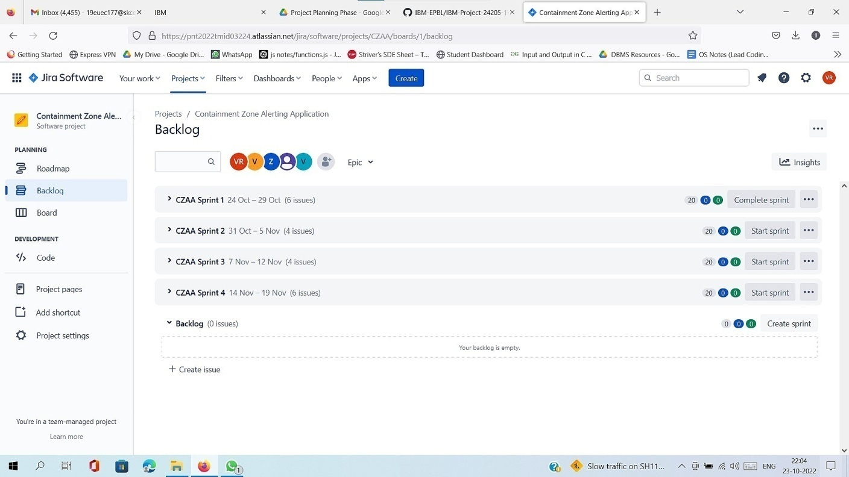

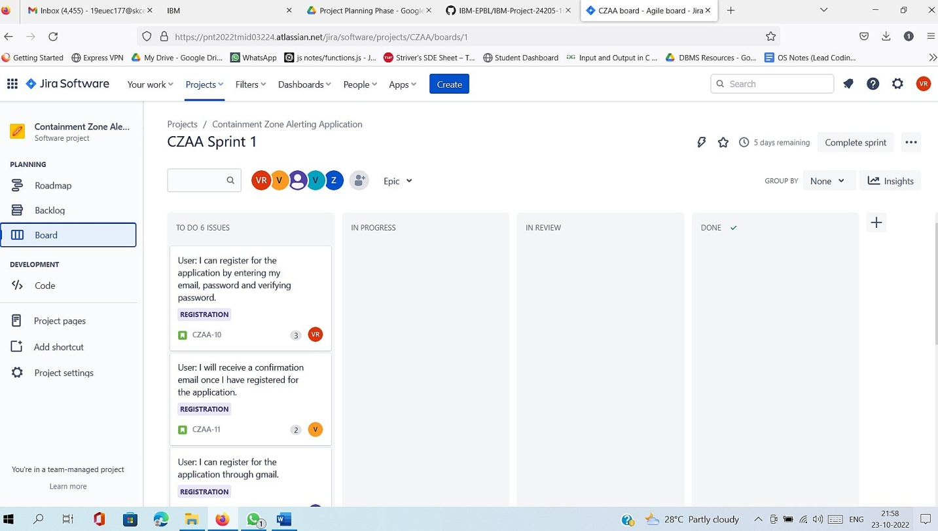

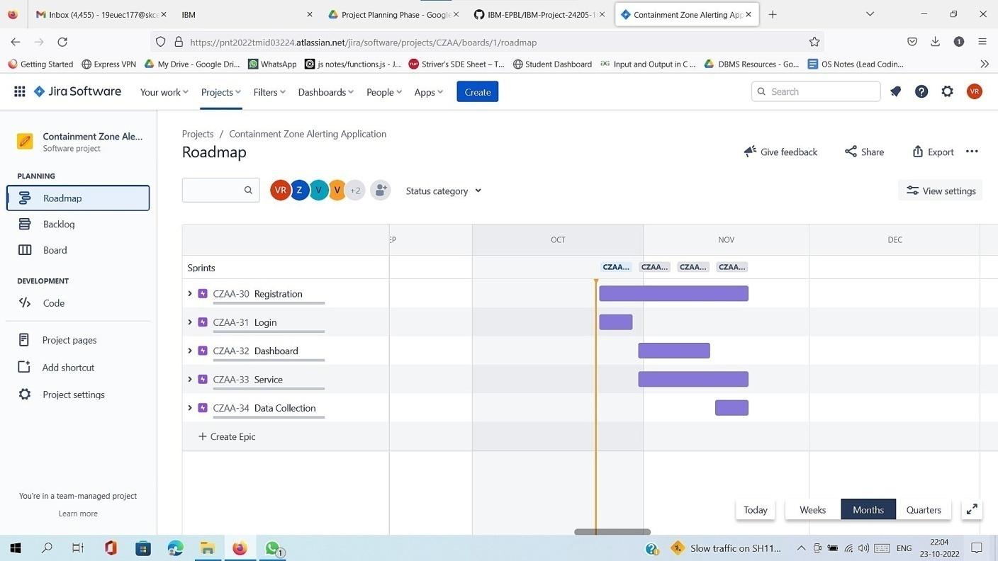

# CODING & SOLUTIONING (Explain the features added in the project along

**with code)**

# Feature 1

## Admin App (portal):

They should login to the app and update the containment zones locations in the portal. Based on the location a Geofence will be created within a 100 meters radius. They should be able to see how many people are visiting that zone.

# Feature 2

## User App (Mobile App):

The app should have a user registration and login. After the user logged into the app it will track the user's location and update the database with the current location. If the user is visiting the containment zone he will get an alert notiﬁcation.

# TESTING

* 1. **Test Cases**

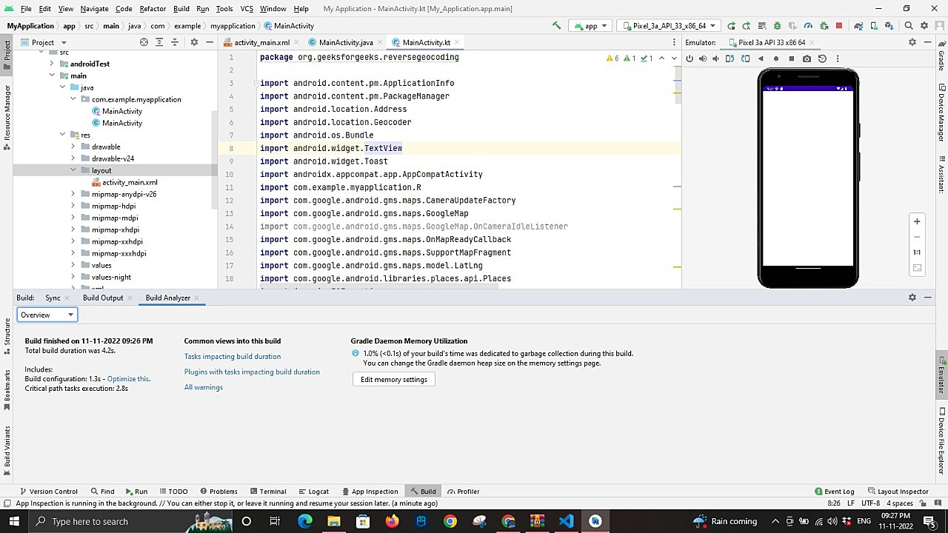

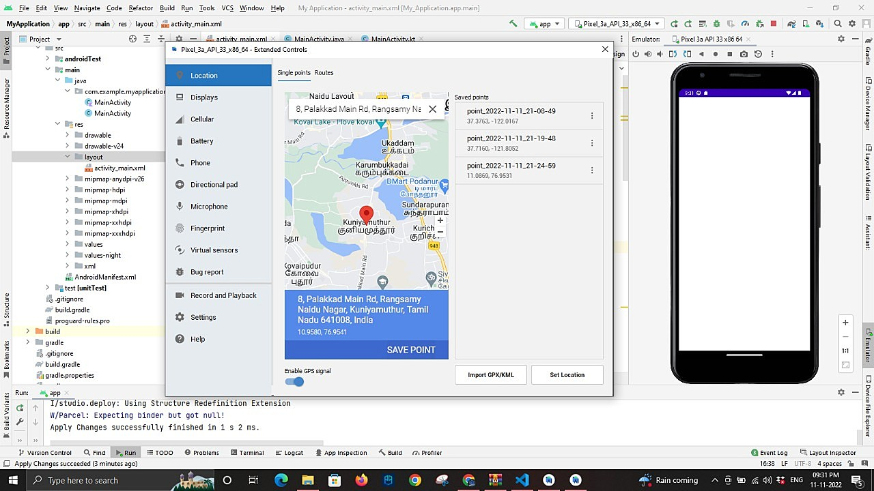

# User Acceptance Testing

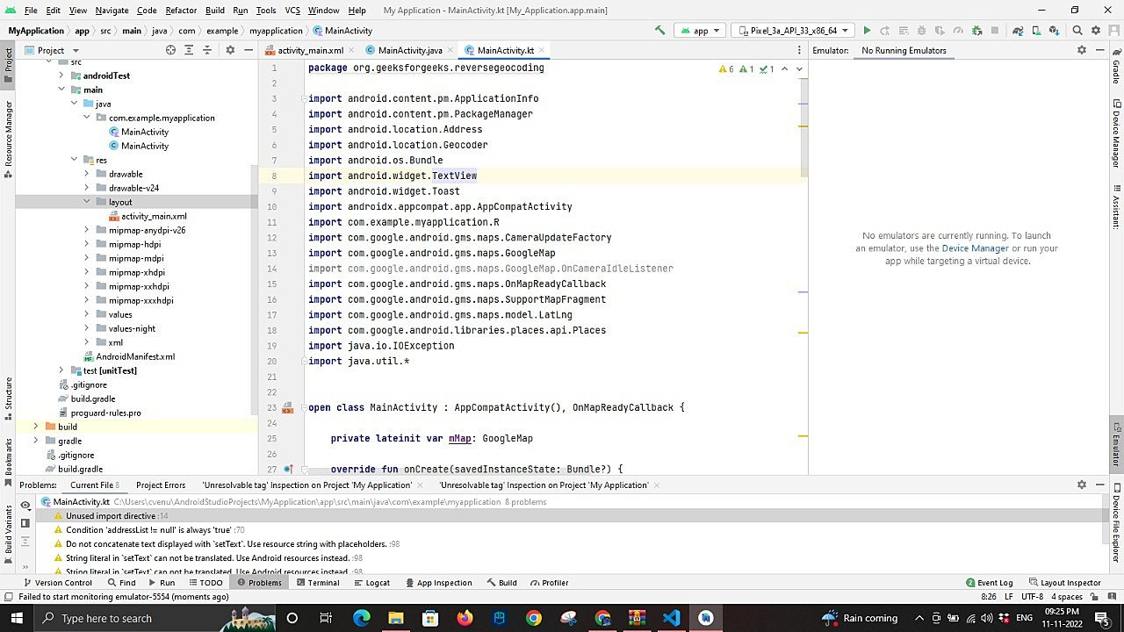

* 1. **Performance Metrics**

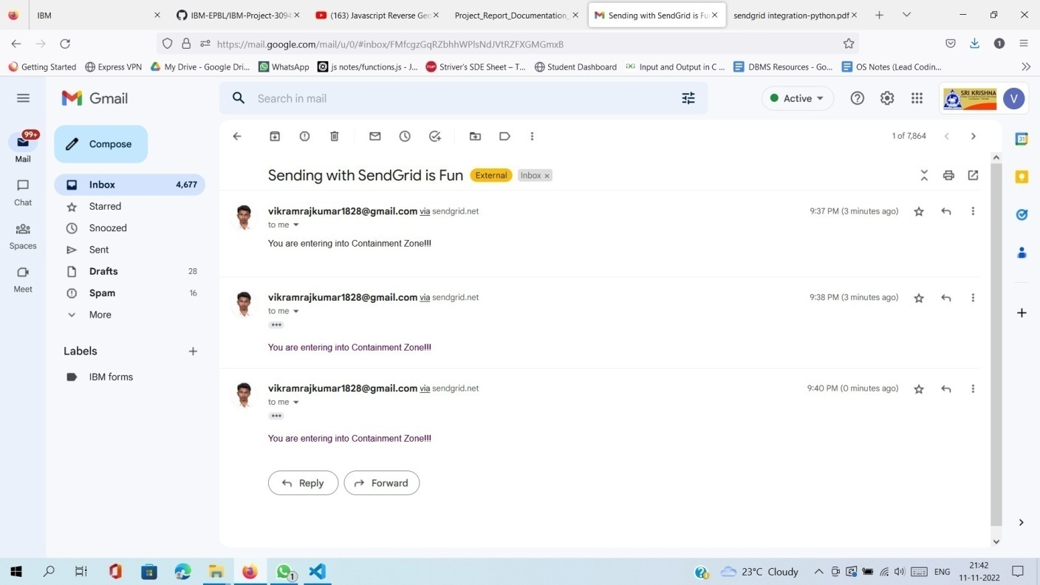

# RESULTS

Tests have been carried out in various containment zones across West Bengal for the validation of the Android application. The identiﬁed containment zones chosen for the testing of the application were visited one by one. It shows various containment zones identiﬁed for conducting the test, the date, time of entry, time of receiving the notiﬁcation alerts upon entering**.** It is highlighted that the application sends notiﬁcation alerts within 5–8 seconds on entering.

# ADVANTAGES & DISADVANTAGES

**1) User Privacy Protection**

Location tracking is enabled by the user and is informed to the user via a ﬁxed notiﬁcation. Before user tests positive for COVID-19 and uploads all his/her locations, the locations are stored in the device’s local storage, none but the user has access to it. Once user tests positive for COVID-19 and uploads his/her locations, the identity of the user is preserved and not accessible to any other user. However, administrative access is enabled for tracking down false claims (not implemented yet) for taking legal actions.

# Eﬃcient Access to potential Huge Server Data Storage

Tracked location data of COVID-19 positive patients will evidently get very large, as the number of affected people is rising each day. Moreover, in many areas people are still reluctant or don’t have the luxury to maintain social distancing. To somewhat make the query process of a possible huge data storage a hashing algorithm is implemented. A particular tracked location is converted into its

corresponding square block/s of area 20 meters x 20 meters along with and hourly time frame.

The block generation is similar to hashing function by providing a key that is the particular index for a query, with the additional beneﬁt that the block also deﬁnes a radius of presence for any particular location. A block is deﬁned by its bottom left and top right diagonal coordinates.

# Anonymous Relief Posts:

Through the app’s global news feed, relief requests can be posted without directly sharing personal or family information of a user. A contact button is attached to relief posts through which any other user can call and contact the relief request post’s author and reach out for help. This feature especially targets the middle-class families that are suffering greatly in silence and cannot seek help publicly. A user is allowed to make only one relief post every seven days, this is a measure taken to stop misuse of the feature.

# CONCLUSION

The application provides an eﬃcient way of showing the identiﬁed Covid-19 containment zones to the users in a Google map. With the alarming increase of Covid-19 affected cases throughout the world, this developed application can be employed as a tool for creating further social awareness among the people. This application further tracks the user's location and checks whether it is present in the list of identiﬁed containment zones. It sends separate notiﬁcation alerts to the user on entering. The developed android application further extracts the IMEI Number of the trespasser in the containment zones which can be useful to the local police to track and identify people who are frequently trespassing the containment zones. Thereby this application identiﬁes the containment zones and highlights the need for taking further precautionary measures for combating

Covid-19. The application has been tested in various locations and has been found to yield accurate results.

# FUTURE SCOPE

The application can be further used for many purposes like maritime and forest safety to prevent users from entering restricted areas.

# APPENDIX

# SOURCE CODE

<!DOCTYPE html>

<html lang="en">

<head>

<!-- basic -->

<meta charset="utf-8">

<meta http-equiv="X-UA-Compatible" content="IE=edge">

<meta name="viewport" content="width=device-width, initial-scale=1">

<!-- mobile metas -->

<meta name="viewport" content="width=device-width, initial-scale=1">

<meta name="viewport" content="initial-scale=1, maximum-scale=1">

<!-- site metas -->

<title>About</title>

<meta name="keywords" content="">

<meta name="description" content="">

<meta name="author" content="">

<!-- bootstrap css -->

<link rel="stylesheet" type="text/css" href="../static/css/bootstrap.min.css">

<!-- style css -->

<link rel="stylesheet" type="text/css" href="../static/css/style.css">

<!-- Responsive-->

<link rel="stylesheet" href="../static/css/responsive.css">

<!-- fevicon -->

<link rel="icon" href="../static/images/fevicon.png" type="image/gif" />

<!-- Scrollbar Custom CSS -->

<link rel="stylesheet" href="../static/css/jquery.mCustomScrollbar.min.css">

<!-- Tweaks for older IEs-->

<link rel="stylesheet" href="https://netdna.bootstrapcdn.com/font-awesome/4.0.3/css/font-awesome.css">

<!-- owl stylesheets -->

<link rel="stylesheet" href="../static/css/owl.carousel.min.css">

<link rel="stylesheet" href="../static/css/owl.theme.default.min.css">

<link rel="stylesheet" href="https://cdnjs.cloudflare.com/ajax/libs/fancybox/2.1.5/jquery.fancybox.min.css"

media="screen">

</head>

<body>

<!--header section start -->

<div class="header_section header_bg">

<div class="container-fluid">

<div class="main">

<div class="logo"><a href="home"><img src="../static/images/logo.png"></a>

<a href="/" style="color: rgba(17, 10, 10, 0.822); font-size: x-large; font-weight: bold;">COALERT</a>

</div>

<div class="menu_text">

<ul>

<div class="togle_">

<div class="menu_main">

<ul>

<li><a href="#"><i class="fa fa-search" aria-hidden="true"></i></a></li>

</ul>

</div>

</div>

<div id="myNav" class="overlay">

<a href="javascript:void(0)" class="closebtn" onclick="closeNav()">&times;</a>

<div class="overlay-content">

<a href="home">Home</a>

<a href="user_map">User Map</a>

<a href="data">Data</a>

<a href="success">Management</a>

<a href="about">about</a>

</div>

</div>

<span class="navbar-toggler-icon"></span>

<span onclick="openNav()"><img src="../static/images/toogle-icon.png" class="toggle_menu"></span>

<span onclick="openNav()"><img src="../static/images/toogle-icon1.png" class="toggle_menu_1"></span>

</ul>

</div>

</div>

</div>

<!-- banner section start -->

<div class="container">

<div class="about_taital_main">

<h2 class="about_tag">About Us</h2>

<div class="about_menu">

<ul>

<li><a href="home">Home</a></li>

<li>About</li>

</ul>

</div>

</div>

</div>

<!-- banner section end -->

</div>

<!-- header section end -->

<!-- about section start -->

<div class="about_section layout_padding">

<div class="container">

<div class="row">

<div class="col-md-6">

<!-- <div class="about_img"><img src="../static/images/img-1.png"></div> -->

<h1 class="about_taital">Government College Of Engineering,Salem</span></h1>

</div>

<div class="col-md-6">

<!-- <h1 class="about_taital">Government College Of Engineering</span></h1> -->

<p class="about_text">We are from Department of Computer Science at Government College Of

Engineering,Salem <br><br>Joy Selvarani <br>Jothika<br>Kamali<br>Kokila<br>Susanthy</p>

</div>

</div>

</div>

</div>

<!-- about section end -->

<!-- footer section start -->

<!-- footer section start -->

<div class="footer_section layout_padding">

<div class="container">

<div class="footer_section_2">

<div class="row">

<div class="col-lg-3 col-sm-6">

<h2 class="useful_text">Resources</h2>

<div class="footer_menu">

<ul>

<li><a href="#">Update the covid zones</a></li>

<li><a href="#">Medical Advice</a></li>

<li><a href="#">Alert Users</a></li>

<li><a href="#">Protection</a></li>

<li><a href="#">Care</a></li>

</ul>

</div>

</div>

<div class="col-lg-3 col-sm-6">

<h2 class="useful_text">About</h2>

<p class="footer_text">We are from Department of Computer Science at Government College Of

Engineering,Salem</p>

</div>

<div class="col-lg-3 col-sm-6">

<h2 class="useful_text">Contact Us</h2>

<div class="location_text">

<ul>

<li>

<a href="#"><i class="fa fa-map-marker" aria-hidden="true"></i>

<span class="padding_15">Salem</span></a>

</li>

<li>

<a href="#"><i class="fa fa-phone" aria-hidden="true"></i>

<span class="padding_15">Call +01 1234567890</span></a>

</li>

<li>

<a href="#"><i class="fa fa-envelope" aria-hidden="true"></i>

<span class="padding_15">demo@gmail.com</span></a>

</li>

</ul>

</div>

</div>

<div class="col-lg-3 col-sm-6">

<h2 class="useful_text">countrys</h2>

<div class="map_image"><img src="../static/images/map-bg.png"></div>

</div>

</div>

</div>

</div>

</div>

<!-- Javascript files-->

<script src="js/jquery.min.js"></script>

<script src="js/popper.min.js"></script>

<script src="js/bootstrap.bundle.min.js"></script>

<script src="js/jquery-3.0.0.min.js"></script>

<script src="js/plugin.js"></script>

<!-- sidebar -->

<script src="js/jquery.mCustomScrollbar.concat.min.js"></script>

<script src="js/custom.js"></script>

<!-- javascript -->

<script src="js/owl.carousel.js"></script>

<script src="https:cdnjs.cloudflare.com/ajax/libs/fancybox/2.1.5/jquery.fancybox.min.js"></script>

<script>

$(document).ready(function () {

$(".fancybox").fancybox({

openEffect: "none",

closeEffect: "none"

});

$(".zoom").hover(function () {

$(this).addClass('transition');

}, function () {

$(this).removeClass('transition');

});

});

</script>

<script>

function openNav() {

document.getElementById("myNav").style.width = "100%";

}

function closeNav() {

document.getElementById("myNav").style.width = "0%";

}

</script>

</body>

</html>